SPRING IN A SMALL TOWN (1948)

*Spring in a Small Town*(*X*iǎochéng zhī chūn),directed by Fei Mu (1906-1951), is one of the classics from the second golden age of Chinese cinema between 1946 and 1949. The film is set in 1946— when China’s full-scale civil war resumed, only a year after World War II—and gives voice to Chinese citizens’ growing resistance to endless war and political turmoil. It tells the story of an estranged couple, Yuwen and her sick husband, Liyan, in a declining intellectual elite family. Their life is disturbed by Zhichen, a doctor of Western medicine, who is Liyan’s old friend and Yuwen’s former lover. His visit to the couple’s rundown mansion—a space that represents the postwar social landscape— provokes them to rethink the meanings of love, family and responsibility. At the end of the film, Zhichen leaves, and the couple’s life goes on amidst the ruins. The film leaves it open as to how their marriage will develop. Carolyn FitzGerald suggests that Fei Mu reveals “a cultural impasse” that modern China faced in the post-WWII era, ‘the result of a lack of faith in Westernized modernity [represented by Zhichen] and an inability to return to a past that has been reduced to ruins’ (2013: 215). However, visually, the film does not leave such a gap between the “modern” West and the “old” China. The director’s insistence on realistic settings, lyrical long takes and expressive high contrast lighting, echoes Italian neorealism and American film noir. And, as many scholars, like Susan Daruvala, Cheuk-to Li, and FitzGerald, also argue, the film—its acting, its dialogue, and its deployment of mise-en-scene—is at the same time deeply rooted in traditional Chinese aesthetics inherited from literature, painting and theatre.

**References and further reading:**

FitzGerald, C. (2013) *Fragmenting Modernisms: Chinese Wartime Literature, Art and Film, 1937-1949*, Leiden and Boston: Brill Academic.

Daruvala, S. (2007) ‘The Aesthetics and Moral Politics of Fei Mu’s Spring in a Small Town’, *Journal of Chinese Cinema* 1(3): 171-187.

Li, C. (2000) ‘Spring in a Small Town, Mastery and Restraint’, *Cinemaya* 49: 59-64.

Pickowicz, P. (2012) C*hina on Film: A Century of Exploration, Confrontation, and Controversy*, Lanham: Rowman & Littlefield.

Udden J. (2012) ‘In search of Chinese Film Style(s) and Techiniques’, in Zhang, Y. (ed,) *A Companion to Chinese Cinema*, Malden: Wiley-Blackwell.

Wu, H (2012) *A Story of Ruins: Presence and Absence in Chinese Art and Visual Culture*, Princeton: Princeton University Press.

**Paratextual materials**

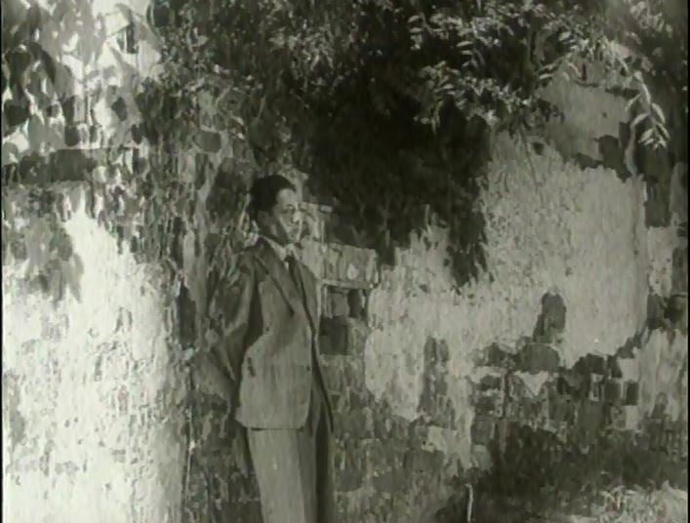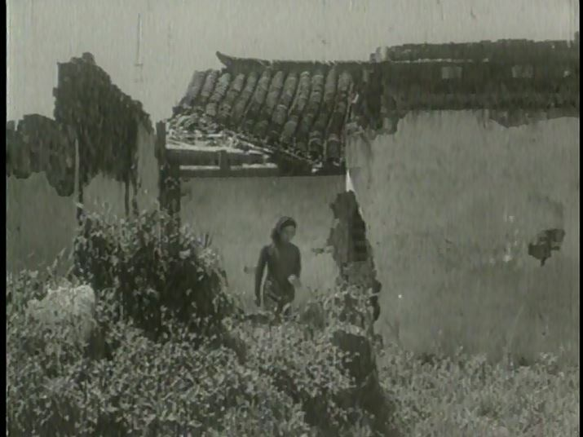Images

Figure 1. Screen Capture from Spring in a Small Town

Figure 2. Screen Capture from Spring in a Small Town

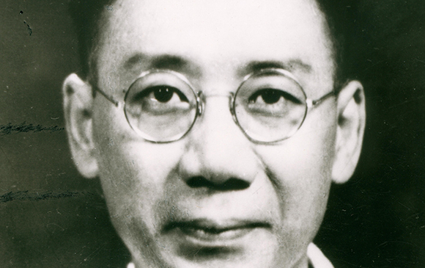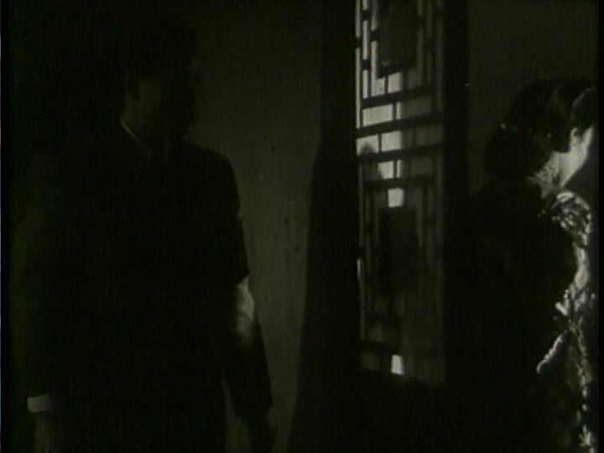

Figure 4. The Director, Fei Mu.

Figure 3. Screen Capture from Spring in a Small Town

**Links:**

Spring in a Small Town at Alt Screen

<http://altscreen.com/09/11/2011/sunday-editors-pick-spring-in-a-small-town-1948/>

Review of Spring in a Small Town at Next Projection <http://nextprojection.com/2013/07/03/tiffs-a-century-of-chinese-cinema-review-spring-in-a-small-town-1948/>

Review of Spring in a Small Town at New York State Writers Institute

<http://www.albany.edu/writers-inst/webpages4/filmnotes/spring.html>

Spring in a Small Town at the Ohio State University Website

<http://people.cohums.ohio-state.edu/denton2/courses/c505/temp/springtown.html>

Funing Tang

University of Miami